The historic recordings of the song "Desafinado:” Bossa Nova development and change in the international scene
Liliana Harb Bollos
Fernando A. de A. Corrêa
Carlos Henrique Costa

Abstract: This article analyzes and compares the versions of the song "Desafinado" on the albums Chega de Saudade, Jazz Samba, The Composer of Desafinado Plays, Getz/Gilberto featuring A. C. Jobim, Sinatra/Jobim and also the sheet music as printed in the books The Real Book, The New Real Book 1, Songbook Tom Jobim and Cancioneiro Jobim. The article takes into account changes and developments in the music scene following the international popularity of the Bossa Nova. We identified that the melodic and harmonic differences on the US album Jazz Samba have interfered significantly in the subsequent sheet music publications and recorded executions of "Desafinado.”

Keywords: Bossa Nova. Desafinado (Off-key). Popular Music. Analysis. Harmony.

1. Introduction

Considered the “turning point” (Medaglia, 1960, p. 79) in modern popular Brazilian music due to the representativeness and importance it reached in the Brazilian music scene in the subsequent years, João Gilberto’s LP, Chega de saudade (1959, Odeon, 3073), was released in 1959 and after only a short time received critical and public acclaim. The musicologist Brasil Rocha Brito published an important study on Bossa Nova in 1960 affirming that “never before had a happening in the scope of our popular music scene brought about such an incitement of controversy and polemic” (Brito, 1993, p. 17). Before the Chega de Saudade recording, however, in February of 1958, João Gilberto participated on the LP Canção do Amor Demais (Festa, FT 1801), featuring the singer Elizete Cardoso. The recording was considered a sort of presentation recording for Bossa Nova (Bollos, 2010), featuring pieces by Vinicius de Moraes and Antônio Carlos Jobim, including arrangements by Jobim. On the recording, João Gilberto interpreted two tracks on guitar: “Chega de Saudade” (Jobim/Moraes) and “Outra vez” (Jobim). The groove that would symbolize Bossa Nova was recorded for the first time on this LP with Elizete Cardoso. This ignited immediate reactions from musicians, critics, and also from the Odeon Record company, which instantly invited João Gilberto to record his first single, Chega de Saudade/ Bim Bom (Odeon 12725/6) in July of 1958. In the end of that year, the second single, Desafinado/Hô-bá-lá-lá (Odeon, 13059) was released. Finally in 1959, Chega de Saudade was released, which was João Gilberto’s first complete LP.
During three years on the Odeon label, João Gilberto released the recordings Chega de Saudade (1959), O Amor, o Sorriso e a Flor (1960) and João Gilberto (1961). Zuza Homem de Mello (2001, p. 62) called these recordings “...a trilogy of exceptional merit that remains as modern as if it had been recently recorded”. In a short time, the Bahian singer imposed a new aesthetic standard on Brazilian popular music, inventing and then weaving a rhythmic dialogue between the voice and acoustic guitar. João Gilberto transformed the acoustic guitar into an instrument which participates in the creative process instead of merely “accompanying” the voice, as it was so common at the time. In addition to this, the rhythmic swing which he trademarked starting with his first recording on the LP Canção do Amor Demais was decisive for many youth interessed in playing acoustic guitar.
In the end of 1961, Capitol released João Gilberto’s recording O amor, o Sorriso e a Flor (Odeon, 1960) on the foreign market under the title, Brazil's Brilliant João Gilberto (Capitol T-10280). In April of 1962, Stan Getz and Charlie Byrd released Jazz Samba (Verve, V6-8432), an instrumental recording that definitively opened the international market to Brazilian music. This version of “Desafinado” contains various melodic and harmonic changes from João Gilberto’s original version. In this sense, we can perceive that it is relatively common to find different written sheet music versions of popular music:
This fact occurs because, different from classical music, which is based on written scores and, therefore, a centuries old tradition of manipulation, editing, sales and composers rights over works, in popular music this fact of (writing out music) is recent, especially since the music is intuitive and improvised
(Bollos, 2010, p. 141).

We have arrived at the quandary of our research: can we define one single version as the principal version or even the original version of a piece in popular music? North American musicians heard the first recording of “Desafinado” on Chega de Saudade and made a new version that was spread around the world. This article is the fruit of qualitative documentary research that discusses various versions of the song “Desafinado”, including the first historic recording on the LP Chega de Saudade (1959), the Getz-Byrd version on Jazz samba (1962), Tom Jobim’s recording on his instrumentalist debut album, The composer of Desafinado plays (Verve, 1963), the LP Getz/Gilberto featuring A. C. Jobim (1963) and the Sinatra/Jobim project, recorded in 1969 but released only in 1995 in the box collection, The Complete Reprise Studio Recordings. Additionally, the research offers a melodic and harmonic comparison of the sheet music in the books, Songbook Tom Jobim (Lumiar, 1994), Cancioneiro Jobim (Jobim Music, 2001), The Real Book (1971) and The New Real Book 1 (SHER, 1995). What was the impact of the above mentioned recordings on the subsequent recordings and sheet music versions of the song in question and which were the ramifications in the international music scene?

2. Bossa Nova’s international scene
In 1960, according to Ary Vasconcelos (1964, p. 28), the singers Ella Fitzgerald and Paul Smith and the trumpet player Roy Eldridge, “...got excited about bossa nova” during a tour in Rio de Janeiro. In 1961, other jazz musicians like Charlie Byrd, Zoot Sims, Al Cohn, Coleman Hawkins, Herbie Mann, and Tony Bennett also found out about this music while on Brazilian ground. Tony Bennett’s bassist, Don Payne, in turn, took some recordings of Bossa Nova to the United States and there showed his neighbor, saxophonist Stan Getz, according to Zuza H. Mello (2001, p. 64). Recorded in February and released in April of 1962, the LP Jazz Samba (Verve) sold, according to Ruy Castro (2002, p. 327), one million copies that year. The Billboard magazine dated 05/05/1962 reported the release of the album. Stan Getz, additionally, released the album Big Band Bossa Nova with Gary McFarland’s big band. Both events preceeded the Carnegie Hall concert in November.
Still in 1962, saxophonist Coleman Hawkins recorded the LP Desafinado in September of 1962. He received critical acclaim from Harvey Pekar, who called the album high quality Bossa Nova music in the magazine Down Beat of 01/17/63. The first vocal version in English of the song was done by Pat Thomas on the single Desafinado (Slightly out Tune), released on Verve (VK-10269), arranged by Lalo Schifrin and produced by Creed Taylor. The magazine Billboard Music Week dated 09/29/62 (p. 33) announced the release of the singer’s album in Chicago on 10/20/1962 (p. 58) and cited that the recording had been well received and that Jazz Samba was in 9th place. Right after that, the singer Ella Fitzgerald recorded the single Desafinado (Slightly out Tune) released on Verve (VK-10274), and Billboard Magazine of 11/93/1962 commented that Ella Fitzgerald’s version had been released that week. Already by the 12/15/1962 edition of the magazine Billboard Music Week, there had been three listings for “Desafinado”: 24th place for Getz and Byrd, 78th place for the singer Pat Thomas and 102th place for Ella Fitzgerald.
Little by little, the simple fact that the idea of a possibile concert at Carnegie Hall with Brazilian musicians managed to form, evidenced the prestige Brazilian music had attained. With the title, “Bossa Nova - New Brazilian Jazz”, the Carnegie Hall concert in New York on November 21, 1962, was a landmark for Brazilian popular music abroad. The North American public came in contact with Bossa Nova played by Brazilians like João Gilberto, Tom Jobim, Luiz Bonfá, Roberto Menescal, Sérgio Mendes, to name only a few. Up until that point, only versions of Brazilian music played by non-Brazilians had been heard.
About the success of the version of Desafinado on Jazz Samba, journalist Flávio de Mattos affirmed:

In mid-1962, Getz was invited to write the theme song for the series, Dr. Kildare, and American TV success. On side B of the recording, Creed Taylor included a reduced version of Desafinado, lasting only two minutes, which included a saxophone solo by Getz and left out the guitar solo by Charlie Byrd. This version of Desafinado exploded on the radios of the United States, becoming a phenomenon that went beyond the jazz audiences. The single brought the sales of the album Jazz Samba up to the 1.6 million copies sold mark. In March of 1963, the recording made it to first place in the Billboard Magazine rankings (Mattos, 2016).

Júlio Hungria cited in his critique in Rio de Janeiro’s newspaper Correio da Manhã, dated 11/28/1962, that “Desafinado” had already been released more than ten times by artists including: Stan Getz & Charlie Byrd, Ella Fitzgerald, Llyd Mayer, Pat Thomas, Freda Payne, Bob Gallo, Contrasts and Julie London, Mavis Rivers and Laurindo de Almeida. In March of 1963, Stan Getz produced another Bossa Nova album, entitled Getz/Gilberto featuring A. C. Jobim, and this time using only Brazilian musicians, including João Gilberto, Tom Jobim, Sebastião Neto, Milton Banana and Astrud Gilberto. It was a huge success in sales and critical reviews and additionally won various Grammy prizes, including best album, best song for “Garota de Ipanema (Jobim/Moraes) and best performance for João Gilberto. In the end of 1963, Antônio Carlos Jobim released on Verve Records his first LP, The composer of Desafinado plays, an instrumental recording with arrangements by Claus Ogerman. Having received positive reviews on this project, in 1967 Frank Sinatra recorded with Jobim the LP Francis Albert Sinatra & Antonio Carlos Jobim, definitively marking Brazilan music internationally.
In the jazz idiom, and later in popular music in general, written out sheet music with melodies and chord changes (lead sheets) was popularized. Starting in the 1940’s, when compiled into a book, the parts initially received the name, Fake Book. Later, with more elaborate and revised parts, the first book in the format, Real Book, was developed at the Berklee School of Music in Boston (USA). This was a joint effort between professors and students to transcribe tunes for the book. It was initially led by the pianist Paula Bley and bassist Steve Swallow and their students. In this manuscript version, and still minus the legal copyrights for the Real Book (1971), the written part for “Desafinado” appears with four missing measures in addition to melodic and harmonic modifications which we will list here.
In Brazil, this format of written out sheet music became popular after the release of the songbooks produced by Almir Chediak and the editing company, Editora Lumiar, starting in 1987. The versions of “Desafinado” in the Songbook Tom Jobim (1994) and more recently in the Cancioneiro Jobim (Jobim Music, 2001) are very similar to the João Gilberto’s 1959 recording. In contrast, the parts in the Real Book manuscript (1971) and The New Real Book (1995) possess melodic and harmonic modifications and the surpression of measures. With respect to this, Tom Jobim himself declared in an interview, “What I find lamentable, in the case of the editors, is that they would have edited my songs all wrong. This is what upsets me. And then it all goes off to the whole world! That is the disaster!” (Jobim, 1994, p. 14). In addition, upon being asked with what type of work he was involved, Jobim emphatically responded, “One of the projects I’m working on is the revision of my own compositions because the editors got everything wrong. They got the melody wrong, the harmony wrong, and the rhythm wrong. And it is is not of any use to leave all of this full of mistakes” (Jobim, 1994, p. 15). He was referring to the book Cancioneiro Jobim, published in 2001.

3. Exploring “Desafinado”
If “Chega de saudade” was the watershed event, “Desafinado” transformed itself into the most significant song of the Bossa Nova movement, becoming a “real manifesto”, for Brazil. Rocha (1960, p. 38). Because of the lyrics to this song, João Gilberto was literally considered to be, by the less informed, an out-of-tune singer. The truth was that Jobim and Mendonça had commented about nightclub singers singing off key and resolved to write a samba that would appear to be a defense of the ‘out-of-tune,’ but that would at the same time be so complicated and full of dissonant traps that, upon being sung by one of them, it would leave them up the river without a paddle (Castro, 2002, p. 205).
About the birth of the song, Marcelo Câmara (2001, p. 47) affirmed:

Newton and Tom had a lot of fun in the apartment at Prudente de Morais. They made lots of critical, ironic, and laughing comments about some of the Carioca night club singers who sang badly out of tune and who they had had to “heroically” accompany on piano. The subject became recurrent in the conversations of both. But now, the observations and critiques had become mockery. And the theme of a song, of a samba that the two were composing (...) would, in all truth, pay homage to and, at the same time, snare these agressors of good musical hearing. (...) In the beginning, for Newton and Tom, taking their turbulent and traditional turns at the piano, the samba was a joke; an intelligent and funny satire. They did not think about recording it or about record sales. The thing is that the piece began structuring itself – the music and the lyrics simultaneously – and when they least expected it, the song was ready. “It got interesting”, they attested.

According to Santuza Naves (2004, p. 84), under the pretext of talking about love, the authors Jobim and Mendonça mutually make commentaries alluding to their own composition process of reversing musical conventions. They reconcile language accessible to the culture of the masses (“I photographed you with my Rolleyflex”) with the effect of the very expensive “oddities” of the historical vanguard of the beginning of the twentieth century. Naves affirms additionally that some Brazilian popular musicians were already exercising a critical posture, but became radicalized starting with Bossa Nova. Actually, according to Câmara (2001, p. 47), the inclusion of the camera Rolleyflex in the song was suggested by Newton Mendonça, who was in love with cinema and photography. He had photographed his wife with his son on her lap with this camera on an occasion. In addition to this, the song is quite atypical. It has dense and difficult harmony, with two large modulations. Its melody is composed of intervals which are difficult to sing in tune, especially by an amatuer singer who cannot sing well.
The partnership between Newton Mendonça and Tom Jobim produced seventeen songs, including “Desafinado”, “Meditação”, “Samba de uma nota só”, Caminhos Cruzados” and “Discussão”. In spite of Jobim becoming known as the composer in the team, he stated that both he and Mendonça wrote the lyrics and the music. “We worked together on the musical part. It was all mixed together. He had the pencil and notebook and I sat at the piano. We did everything together. It was different from what I do, for example, with Chico Buarque” (Jobim, 1994, p. 12). Mendonça died in 1960 at age 33 and did not witness the success of his music. According to Tárik de Souza (2003, p. 191), Mendonça’s work was undervalued. One mishap in the production of the single “Desafinado” (Mendonça/ Jobim) and “Ho-ba-la-lá” (João Gilberto) also favored Mendonça’s lack of recognition, as Câmara tells:

Absurdly, in the center of the 78 released by João Gilberto (Odeon Rio 13094-14426), was written: “DESAFINADO (Antonio Carlos Jobim)”. Newton’s name was left out. A second pressing included the partner’s name, but was printed incorrectly: “DESAFINADO (Antonio Carlos Jobim – Milton Mendonça)” (Câmara, 2001, p. 48).

It could perhaps be said that the fact of Newton Mendonça being less remembered by the media and public is because of his precocious passing and also because of his name had not appearing as co-author of the song “Desafinado”. On the other hand, the composer Carlos Lyra, cited by Câmara, explains how the question of copy rights for music from various composers in Brazil works and how it was with the Jobim-Mendonça partnership:

Authentic partnership. Newton Mendonça is an authentic partner of Tom Jobim. ‘Authentic partnership,’ an ancient expression, is understood to be where authors participate equally in writing music and lyrics. (...) It is an international convention, little observed in Brazil, this system of presenting the authors of a musical work in such a way that the name of the musician preceeds the name of the lyricist. In the case of the partnership, for example, between Newton Mendonça and Tom Jobim, there is an impasse over which name should preceed which (Lyra apud Câmara, 2001, p. 84).

After Brazilian popular music’s international recognition and broad dissemination following the Carnegie Hall concert, Jobim understood the necessity of protecting the copyrights to his music and traveled to the United States. This trip was commented on by Vinicius de Moraes in his column, “Bossa Nova” dated 11/12/1964 in the newspaper, Diário Carioca in the review “On a really sad note”:

Leaving today for the United States is my dear friend and partner on his mission (and I know nothing more beautiful): to defend the ever growing prestige of our popular music, of which he was the main protagonist, thanks to the lyrical beauty of his best sambas and songs (...). There he goes, nonetheless, to confront the hardness and thickness of the American editors and the lack of sensibility of the professional lyricists to direct the truthful preservation of his songs (...) Three days ago, I saw him apply for a loan to be able to travel (...) But that is not a problem. The money will arrive, without a doubt. His songs are, in this exact moment, even as I write these lines, played hundreds of times in Europe, in the United States, and here, on our continent (...) You are bringing more prestige and currency exchange to Brazil (Moraes, 1964, p. 7).

One decade after this affirmation from Vinicius de Moraes, the first North American books and sheet music began to be disseminated. The version of “Desafinado” that appears there is that of Getz-Byrd, containing diverse melodic and harmonic changes. This is the version disseminated in the North American musical environment. Not even the beautiful version of Getz/Gilberto with Jobim’s participation was taken into account.
The structure of “Desafinado” is written in the AABA form, however the number of measures is quite distinct from the classic format of 32 bars with 8 measures in each part, as in songs like “Só Danço Samba” (Jobim) and “Take the ‘A’ Train” (Ellington/ Strayhorn), and so many other popular songs. In all five of the recordings of “Desafinado” cited here, the number of measures for the AABA form is 68. We opted to identify and number the parts that compose the form of the music as A1 (16 bars), A2 (16 bars), B (16 bars) and A3 (20 bars). This is because, inspite of parts A, A1, and A2 containing the same motif, they are quite diverse in and of themselves. This is different from the classic format in which melodic and harmonic differences appear only in the two final measures of part A.

3.1. Comparisons between the versions of “Desafinado”
Among the analyzed recordings, the versions of “Desafinado” on Chega de Saudade, Sinatra/Jobim and The composer of Desafinado plays are in E major. The recording on Getz/Gilberto featuring A. C. Jobim is in E flat. The recording on Jazz Samba, along with the versions in all of the books, is in F major. For this reason, the key of F has been chosen to be used to facilitate the comparison between the versions.
This song possesses an introduction (figure 1), which is also refered to as a verse. It is transcribed in the book, Cancioneiro Jobim, and has been recorded by only a few musicians. Of those who have recorded it, we highlight the recordings of Tom Jobim: The composer of Desafinado plays (1963), Terra Brasilis (1980), Inédito record 2 (1987), Sinatra/Jobim (1995), Minas Ao Vivo- Piano e Voz (2004) and the recordings Você Ainda Não Ouviu Nada (Philips, 1964) by Sérgio Mendes & Bossa Rio and Ella Abraça Jobim (Pablo Records, 1981) by singer Ella Fitzgerald.

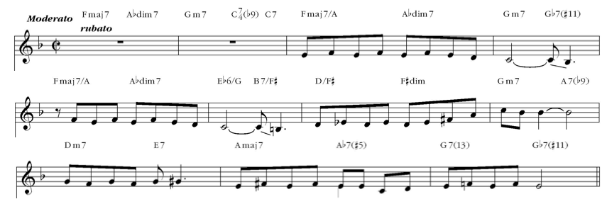
Figure 1: Introdution. “Desafinado” Cancioneiro Jobim.

The two final measures of the introduction repeat themselves during the theme in measures 29-32 with the same melodic and harmonic sequences. However, in the version from Sinatra/Jobim, the singer does not repeat in the theme the melody of the verse, as shown in figure 6.
Next, we compare the melodic and harmonic differences that exist between the versions based on the written music in the Songbook Tom Jobim and Cancioneiro Jobim. We consider measure 1 to be the exposition of the theme and divide the analysis into the form A1, A2, B and A3:

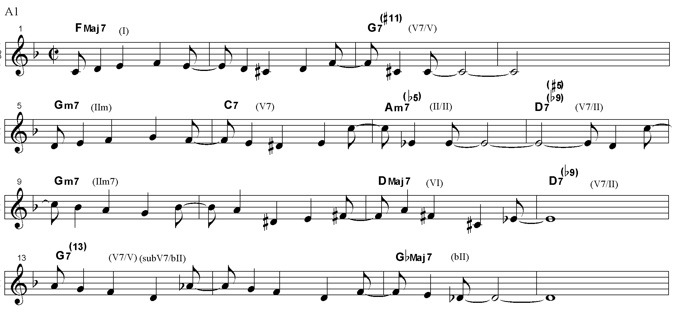
Figure 2: Cancioneiro Jobim, part A1, measures 1-16.

The relationship between melody and harmony in a piece of music determines situations of increased tension, sophistication, or even dissonance. This relationship happens when the strong beat of a melody rests over a very expressive harmony note. Many times this can be dissonant. When this harmonic note is supported by degrees above the notes of the tetrachord (root, 3rd, 5th, and 7th), we call the tensions “higher degrees” like 9, ♭9, #9, #11, 13, and ♭13. If a specific melody possesses one or various higher degrees, it is considered to be more sophisticated, uncommon, and unexpected. In “Desafinado”, the moment João Gilberto sings the first phrase “se você disser que eu desafino, amor,” the word “amor” carries a great deal of tension because the melody is supported at the interval of an augmented fourth (C sharp), or the #11th of the G7 chord (V7/V). In measure 3, in the books Songbook Tom Jobim and The Real Book (manuscript and printed), it is spelled as a diminished fifth (D flat), as in figure 3. However, we have spelled it as in the Cancioneiro Jobim, with the 11th augmented (C sharp), as in figure 2. For us, it is a dominant chord with an augmented 11th, a tension note that is placed above a tetrachord, which can be executed also with a major 9th and major 13th, thus forming the lydian dominant scale, or Mixolydian #11.
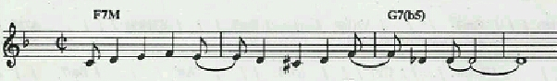
Figure 3: Songbook Tom Jobim, measures 1-4.

According to Gekas, the harmonic treatment of “Desafinado” is characterized by superstructure chords. The triads and tetrachords are added ninths, elevenths, and thirteenths. “These tension notes, which are many times melody notes, produce a texture characterized by dissonance in the relationship between each chord tone or between the melody line and the bass line” (Gekas, 2005, p.94).
In the first part (A1), we encounter rhythmic differences between the two Jobim songbooks that compromise neither the melodic nor the harmonic aspects. The 1st, 5th, and 13th measures serve as examples. In the Cancioneiro Jobim, an eight note rest preceeds the melody and in the Songbook Tom Jobim, the melody begins on the first beat of the first measure. Therefore, this sudy will not make observations related to the rhythmic aspects that appear in the various versions.
With relation to the version of “Desafinado” on Chega de Saudade, João Gilberto plays some chords on the acoustic guitar which differ from the songbooks. In measures 8, 12, and 24, he plays an A diminished (A^{dim}) where the written part says D7^{(b9)}, or D dominant, the secondary dominant chord of the second degree (Gm). This diminished chord has a dominant function, which means we can substitute D7^{(b9)} for A^{dim} and the dominant function will prevail.
In measure 11, the written part in The New Real Book, as seen in figure 4, spells a dominant chord. Even so, there is no version in which the D⁷ chord appears. Instead the chord D^{7M} appears. In the same measure on Jazz Samba version, the note that preceeds the E flat is a D (figure 4), but in the original version (figure 2), it is a C sharp.
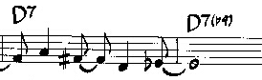
Figure 4: The New Real Book, measures 11-12.

In measure 13 (figure 5), we find in Jazz Samba a melodic and harmonic difference when the note A flat appears in two measures with the accompaniment of the dominant chord G^{7(b9)}. In João Gilberto’s version and all the rest of the versions in which Jobim takes part, in the 13th measure the melody is the note A, the ninth degree of G⁷⁽⁹⁾ and in the previous measure it is A flat, the minor ninth of G^{7(b9)}.
Figure 5: Jazz Samba, c. 13-15.

Still looking at figure 5, in measure 15, on Jazz samba the note D flat is repeated while the original version in figure 2 shows that we have the notes E and D flat. Similar to the versions of figure 5, we have the recordings of Ella Fitzergald and Pat Thomas and of the realbooks.
Next, in the measures 17-32, which we call A2, there is a new exposition of the theme with development and preparing for the modulation in part B:

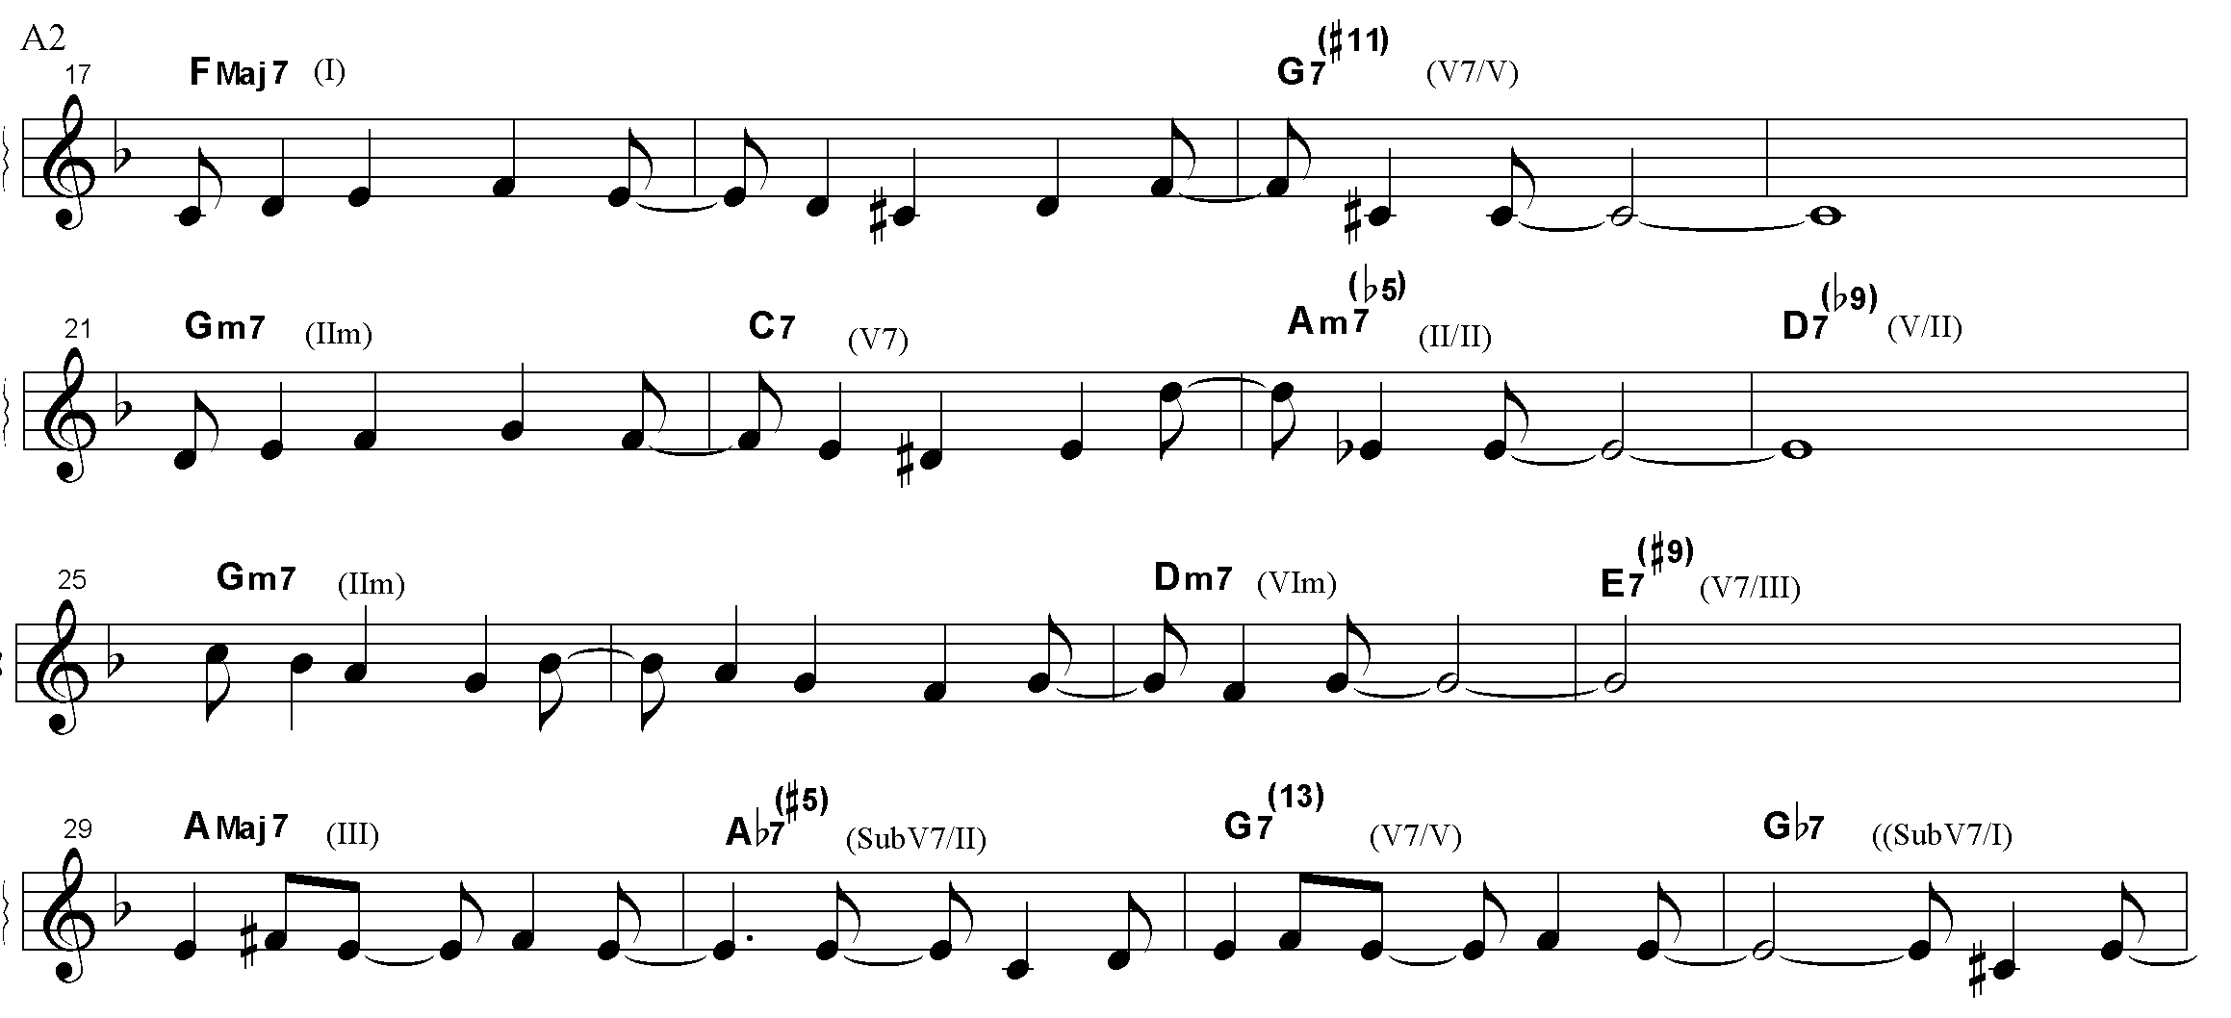
Figure 6: Songbook Tom Jobim, part A2, measures 17-32.

In the exposition of the first theme (A1, measures 1-16), in the last two notes of the melody in measure 6, there is a melodic interval of a descending minor 6th between the notes E and C. This creates, in the melody, the third (the note C) of the A half-diminished chord. In measure 22, the second time in which the melody is presented, there is a modification in the melody. The last note of the measure is the note D, which creates the interval of a descending major seventh, the 11th of the A half-diminished. In the version on Jazz samba, this modification is not present, nor in the books Real Book (manuscript) or The New Real Book. There the written parts possess a repeat sign indicating the same A. Other recordings cited here repeat the Jazz Samba version: the recordings of Sérgio Mendes e Bossa Rio, of Ella Fitzgerald from 1962 (single) and the LP Ella Abraça Jobim from 1981. In this excerpt (measures 22-23), the singer Pat Thomas sings according to the original version.
In measure 28, João Gilberto plays on the guitar the B diminished chord (B^{dim}), a diminshed with a dominant function (E⁷) and the written parts spell the chord as E^{7(#9)}, causing the dominant function of the diminished chord to predominante. On the Sinatra-Jobim version, in measure 28 the chord E7^{(#9)} is played. Another difference happens in measures 29-32 in the section where the lyrics read, “isso é bossa nova, isso é muito natural”. The Jazz samba version plays, in the 30th measure, the note C sharp instead of C natural, which dictates a different harmonic sequence, as shown in figure 7:
Figure 7: Jazz Samba, measures 29-32.

The version of Jazz samba above (figure 7) provides an authentic cadence A – Bb^{dim} - Bm – E⁷ (I – V⁷/II – IIm⁷ – V⁷) very different from the original version which contains a progression of descending substitute secondary dominant chords which will not resolve, culminating in the desceptive cadence (A^{7M}, Ab⁷, G⁷, Gb⁷, A^{7M}). For Gekas, after the resolution of the A^{7M} chord (T), a sequence of subsititute dominants which finalize in the Gb^{7 (b13)} is verifiable. “This chord can be interpreted either as a Dsub (secondary dominant) of the sixth degree of A minor or the first of F major: F^{7M”} (GEKAS, 2005, p. 99).
In the second part of the music (figure 8), in measures 33-48, the modulation from F to A is confirmed.

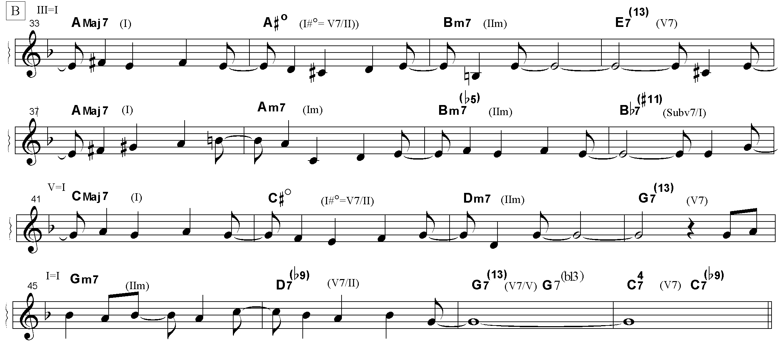
Figure 8: Songbook Tom Jobim, part B, measures 33-48.

In part B there is a modulation from F to A and a new motif appears in that A^{Maj7} (measures 33-40) modulates to C (measures 41-48) to finally reach the return to part A which is in F (measures 49-68). Once again, some melodic and harmonic modifications can be perceived in the Jazz Samba version. In measures 37-40, the note C natural is subsituted for C sharp in measure 38. Additionally, the F natural in João Gilberto’s original version is subsituted by an F sharp, modifying the harmony once again, as seen in the following excerpt:
Figure 9: Jazz Samba, measures 37-40.

In the A3 section, the original theme returns and the form is finalized with 68 measures. The A3 section has four measures more than the other parts: 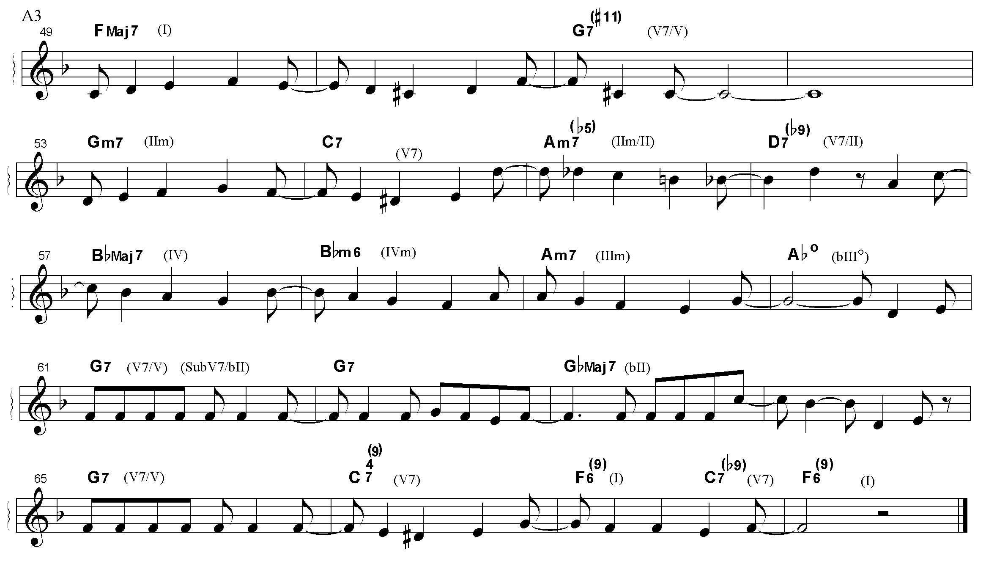
Figure 10: Songbook Tom Jobim, part A3, measures 49-68.

In measure 57, the Jazz Samba version modifies the original melody sung by João Gilberto on Chega de Saudade.The Real book spells this in the same way as the Jazz Samba version, as seen in the figure below:
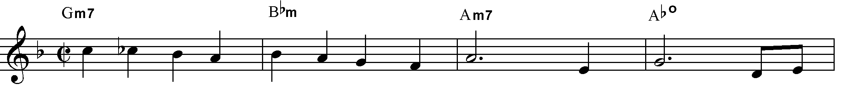
Figure 11: Jazz samba and The Real Book versions, measures 57-59.

It can still be observed in measure 57 that in Jazz samba and in the two American real books, the chord Gm7 (IIm) substitutes Bb^{7M} (IV). Although there is a chord change, the subdominant function prevails. In measure 59, the Songbook Tom Jobim spells this as Am7 (IIIm). João Gilberto, on Chega de Saudade plays an F^{7M}/A, an acoustic guitar language specialty. The Jazz Samba version uses F^{7M} (I). Here the tonic function prevails. Moving to measure 60, in which the melody rests on the note G, there are various versions of the chord changes. A flat diminished is used in the two Jobim songbooks, in The Real Book and on Sinatra/Jobim. D minor (DM) is used on Chega de Saudade, The composer of Desafinado Plays and on Getz/Gilberto featuring A. C. Jobim. Finally, G dominant (G7) is used on Jazz Samba. The written part in the book, The New Real Book 1, spells the chord D minor (DM) and the chord G7 is in parenthesis.
Finally, in measures 63-64, the chord Gb^{7M}, a modal interchange chord and extension of the Bbm subdominant minor is used in the four recordings Tom Jobim plays on and in the Brazilian songbooks. However, on the Jazz Samba recordings, Bb minor is played and the books, The Real book and The New Real Book 1, list the chord spellings of Bbm7 (measure 63) and Eb7 (measure 64). We observe that, in measures 63-64 of the Getz/Gilberto version, the harmony plays Gb^{7M} and the bass plays Eb. This leads us to believe that the harmony Eb^{sus7(9)} or Bbm7/Eb can be thought of, which is also a modal interchange chord. On the Pat Thomas version, a Gm in the place of a G7 appears in measure 65.
With respect to the two vocal versions, we notice that that singer Ella Fitzgerald’s version from November of 1962 uses as a basis the version from Jazz Samba. On the other hand, singer Pat Thomas’ version from September of 1962, considered the first version of the song in the English language, is more faithful to the Brazilian version from João Gilberto. This one has only two melodic differences, as seen in figure 5 and figure 8, measure 39, where she sings F sharp. This version, however, is little known.

Final Considerations
We have analyzed the recordings of “Desafinado” on Chega de Saudade (1959), on Jazz Samba (1962), on The Composer of Desafinado Plays (1963), on Getz/Gilberto featuring A. C. Jobim (1963) and on Sinatra/Jobim and the written music in the books The Real Book (1971), The New Real Book 1 (1995), Songbook Tom Jobim (1994), and Cancioneiro Jobim (2001). We have seen, therefore, five versions of the song. Four of them have one of the authors of the song (Tom Jobim) acting as arranger and/or performer. We notice that there was a consensus when Jobim participated in the four versions since there only one melodic and harmonic change in the Sinatra/Jobim version in measures 29-30 (figure 7), differing from the other versions.
The Jazz Samba version, on the other hand, posseses various melodic and harmonic alterations, but reached the international market more quickly than the other versions. The written parts for “Desafinado” transcribed in The Real Book (manuscript) and in The New Real Book 1 are in the key of F major and possess the same melodic and harmonic modifications as the Jazz Samba version pointed out in this study. It is noticed, therefore, that in the foreign books, the Jazz Samba version prevails. The version of the song discussed in the dissertation by José Estevam Gava (UNESP, 1994) and poured over in the book A Linguagem Harmônica da Bossa Nova (Ed. UNESP, 2008) also takes the Jazz Samba version into consideration. Jazz Samba is from 1962. It is relevant, therefore, that the first observed recording of “Desafinado” was João Gilberto’s from 1959. In spite of the Getz/Gilberto featuring A. C. Jobim having been released in 1964 and having received inumerous prizes, the version of “Desafinado” transcribed in the two books called the Real Book is that of the Jazz Samba recording. Many other recordings and publications of written parts have been released, spreading different versions of these compositions around and interfering, above all, in the later performances of this song.
The five versions of the song “Desafinado” discussed here are of great artistic value. João Gilberto introduced dialogue between voice and acoustic guitar. Stan Getz and Charlie Byrd brought jazz improvisation. Tom Jobim presented an instrumental version in which the piano provides the melody. Gilberto and Getz provided a partnership that transcended jazz frontiers. Finally, Sinatra and Jobim united the most popular singer of the age with the great Brazilian composer.
Bossa Nova opened new esthetic areas for our culture and obliged others to take a second look at Brazilian popular music. Conquering ever-increasing visibility and assimilation, Bossa Nova has been spread by artists over the whole world. May our music be interpreted, printed, revised, and spread throughout the world and may musicians be encouraged by becoming familiar with and transcribing the first versions of historic recordings so that they understand, above all, that they are performing original versions of Brazilian music. After all, for a musician, educator, and music researcher, to express onself with music, through music, and in music should be a revival of one’s own culture.

Bibliographic references:

AURWIN, Nicholas; The Jazz Sippers Group. The history of Jazz and the Jazz Musicians. Lulu Press Inc. 2009. (E.book)
Billboard Music Week. Hot 100. 15 dec. 1962. Available in: https://books.google.com.br/books?id=KRgEAAAAMBAJ&pg=PP4&dq=desafinado++billboard+getz+pat+ella&hl=pt-BR&sa=X&ved=0ahUKEwjB9qCAkoDOAhWEQpAKHV47DfMQ6AEIJjAB#v=onepage&q=desafinado%20%20billboard%20getz%20pat%20ella&f=false. Accessed on March 17, 2016.
BOLLOS, Liliana Harb. Bossa nova e Crítica: polifonia de vozes na imprensa. São Paulo: Annablume/FUNARTE, 2010.
______. A bossa nova no exterior: duas versões de Desafinado. Anais do V Simpósio Internacional de Musicologia, Escola de Música e Artes Cênicas da Universidade Federal de Goiás, Pirenópolis, p.77-83, 2015. Available on: http://media.wix.com/ugd/c1b035_11ed326d20914d04b772b5f0ad50bade.pdf. Accessed on: May 26, 2016.
BRITO, Brasil Rocha. Bossa nova. 1960. In: CAMPOS, Augusto de, Balanço da bossa. São Paulo: Perspectiva, 1993.
CÂMARA, Marcelo. Caminhos cruzados: A vida e a música de Newton Mendonça. Rio de Janeiro: Mauad, 2001.
CARDOSO, Elizete, Canção do amor demais, Rio de Janeiro, Festa, FT 1801, 1958. 1 CD.
CASTRO, Ruy. Chega de saudade: a história e as Histórias da Bossa Nova. 3. ed. São Paulo: Companhia das Letras, 2002.
FITZGERALD, Ella. Desafinado (Slightly out of tune). Los Angeles, Verve Records, VK10274, 1962, 1 Single.
HUNGRIA, Júlio. No caminho do Carnegie Hall. Correio da Manhã, Nov. 28, 1962, 2. Caderno, p.1.
GAVA, José Estevam. A linguagem harmônica da Bossa Nova. 2. ed. São Paulo: Ed. Unesp. 2008, p.126-129.
GEKAS, Paulo Demetre. Correlações entre Desafinado e Moon dreams: uma análise dos processos lineares e harmônicos. Dissertação. (Masters in Education and Culture). Universidade do Estado de Santa Catarina, Santa Catarina, 2005.
GETZ, Stan; BYRD, Charlie. Jazz samba. Verve. EUA. V6-8432. 1962. 1 CD.
GETZ, Stan; GILBERTO, João. Getz/ Gilberto featuring A. C. Jobim. Verve 314521-414, 1964. New York. 1 CD.
GILBERTO, João. Chega de saudade. Rio de Janeiro, EMI-Odeon 3073, 1959. 1 CD.
GOLD, Michael; VILLA, Dario. Tradings fours: Jazz and the learning organization. Milano: Art for Business Edizioni, 2012.
HAWKINS, Coleman. Desafinado. Impulse. A28. 1962. 1 LP.
JOBIM, Antônio Carlos. Entrevista. In: Songbook Tom Jobim.V.2. Rio de Janeiro: Lumiar, 1994, p.16-18.
______. Cancioneiro Jobim. Rio de Janeiro: Jobim Music, 2001.
______. Songbook Tom Jobim. V.3. Rio de Janeiro: Lumiar, 1994, p. 39-41.
LEONARD, Hall (Editor). The Real book. Milwaukee, WI: Hal Leonard, 2004.
MATTOS. Flávio de. O Desafinado sucesso da Bossa Nova de Charlie Byrd e Stan Getz em Jazz Samba. O Globo. Blog do Noblat. Available on: http://noblat.oglobo.globo.com/artigos/noticia/2016/08/o-desafinado-sucesso-da-bossa-nova-de-charlie-byrd-e-stan-getz-em-jazz-samba.html .
MELLO, Zuza Homem de. João Gilberto. São Paulo: Publifolha, 2001.
MORAES, Vinicius de. Bossa nova em tom bem triste. Diário Carioca, Rio de Janeiro, Nov. 12, 1964.
NAVES, Santuza Cambraia. A canção popular entre a biblioteca e a rua. In: Decantando a república: outras conversas sobre os jeitos da canção. Rio de Janeiro: Nova Fronteira, 2004, p. 79-96.
PEKAR, Harvey. Revista Down Beat. V.30. N. 2, Jan. 17, 1963.
Sinatra/Jobim. The Complete Reprise Studio Recordings. Los Angeles. Reprise, 1995. 1 CD.
SHER, Chuck (org.). The New Real Book 1. Petaluma EUA: Sher Music Co., 1995. p. 65-66.
The Real Book (manuscript). 1971, p. 112-113. [s.n.] (written part).
THOMAS, Pat. Desafinado. Verve VK-10269. New York. Available on: https://www.youtube.com/watch?v=nrdzKB0r_HE. Accessed on June 15, 2016.
VASCONCELOS, Ary. Panorama da Música Popular Brasileira. Vol.1. Rio de Janeiro: Martins, 1964.

The first version of this article was published in the Anais do V Simpósio Internacional de Musicologia (Bollos, 2015), in which two versions of “Desafinado” were discussed. The Chega de Saudade and Jazz Samba versions were a development of the Bossa Nova and Criticism discipline adminstered by the author at the Universidade Federal de Goiás, as part of her postdoctoral research funded by CAPES-PNPD.
The term Real Book is generic. It can refer to compliations of lead sheets for jazz songs, but it also refers to the first volume of a series of books transcribed by students and professors at Berklee College o Music in the 1970’s. Gold e Vila (2012, p. 41-42) and Aurwin (2009).

