

Use of Mobile Devices in Participative Documentaries in the Settlements of Landless Rural Workers Movement in Brazil

Felix Rebolledo Palazuelos
UFRGS/Porto Alegre/Brasil
rebfel@gmail.com
Andréia Machado Oliveira
UFSM/Santa Maria/Brasil
andreiaoliveira.br@gmail.com
Introduction
Our paper examines the theoretical aspects of the "Production of Participative Documentaries in the Settlements of the Landless Rural Workers Movement in Brazil" research project that deals with the use of mobile digital devices to create new subjectivities and generate social actions within the settlements of the Landless Rural Workers Movement in the state of Rio Grande do Sul, Brazil. We draw upon the appropriation of mobile digital devices to establish links between the creation of subjectivity as emergent identity and the detection of memory as integrative process within social movement. To activate our theoretical framework in praxis, we situate mobile devices at the intersection of environmental, social and mental ecologies within Art and Technology under the aegis of Guattari's ethic-aesthetic paradigm.
As such, we seek to generate an enabling ecology of practices, which repositions the functionalities of digital technologies and the potentials of web-based social media. We examine the micro-politics of the quotidian as well as memory as integrative of experience to bring forth singularizing experiences through the production of videos. In our project, both sender and receptor become generators of content mediated through a network of connectivity, which provides singular local value within global connections. This entails a shift from considering technologies and media as technological entities towards the activation and realization of difference towards the invention of a subjective society which Guattari saw as being “created within the perspective of a new aesthetic-political paradigm" (Guattari, 1995). For both, Guattari (1995) and Simondon (1958) technology defines an active and vital realm of potential not as a means, but as constitutive of an enabling ecology that interlinks aesthetic and ethical concerns.
From a technical standpoint, digital technologies provide popular access to the means of production of content whereas web-based social media provide unprecedented possibilities for dissemination and distribution of cultural production. In turn, mobile devices simultaneously bring into play the immediacy of ease of use, ubiquity and flexibility by prompting mobility to re-texture the give-and-take of the informational landscape as well as colour the experience of production. Location is thus no longer considered a stable center: location becomes a nomadic quality—an ambulating attractor of unsettled intensifications—as it becomes activated by the displacement of the user and the mobile technology.
As a territorializing technology, mobile devices and the indefiniteness of location lead us to reconsider the conception of cognitive subjects and their spaces of occupation as identity. The way we currently use wireless devices has transformed them from mere passive data-capturing devices into active agents of production, reception and distribution of information. Combined with locative media, creators can activate or provide access to additional channels of sited information on the most diverse aspects of an environment while generating new hybrid bodies, which simultaneously inhabit physical locations and the cyberspace. This enhanced informational landscape composed with mobile devices—commonly referred to as a mobile augmented reality—creates communicated territories, both in the sense of being linked as well as being involved in the exchange of information, as hybrid spaces of digital-informational control and mobility but which are not necessarily physically connected.

Location as a Nomadic Quality
The proliferation of ubiquitous computing and mobile media have transformed the landscape of public space. The use of mobile devices allows one to speak on the phone in the bus, to send text messages while walking down the street or perform other activities representing “experiences of private life in the midst of the accelerated movement of the everyday in contemporary public spaces” (Santaella, 2008, p. 130). Individuals in motion can thus communicate and interact through digital media technologies in cyberspace while being minimally aware of the place they occupy in space. Cyberspace does not eliminate the idea of physical space; the two become hybridised the moment that information pertaining to the physical space is made available within virtual contexts and that the virtual space is mapped onto the physical space, thus “the public sphere arises from the complex interaction of material and immaterial spaces in hybrid spatialities characterized by dynamic flows” (p. 130).
The world becomes mediated by information as a territorializing technology, which is subsidiary to mass communication and the whims and preferences of the user. “The location becomes the subject of action: the information “emanating” reacts to and from it” (Lemos, 2010, p. 2). Informational flow generated by control and distribution systems as the center ceases to be the model and is added by post-mass media formats "which allow the free and extensive production, consumption and circulation of information" (p. 4). However, all mediation, whether mass media or post-mass media, leads us back to material culture—we inevitably relate to the world through artificial mediators, namely language, institutions or technological devices.
Lemos (2009) asserts that the hybridization of physical space and cyberspace is what characterizes the era of ubiquitous communication. Post-mass locative media facilitate the appropriation and distribution of information across networks thus allowing expressive relations to emerge between cyberspace and urban space. In this way, post-mass locative media produce informational territories where the movement of incoming and outgoing information as an open system is constitutive of new corporalities which together produce associated milieus as cognitive subjective entities.
Communicational Considerations
The power of mass media to define and sway public opinion constitutes one of the most powerful forces in defining and modulating how the citizenry thinks, perceives and acts socially, politically and culturally in the world. Media are also leading determinants as to how the citizenry will accept the legitimacy of government and submit to governability: in the battle over the hearts and minds of people, the effects of media and mass communication are of paramount importance and require a new understanding which reflects the new social, political and cultural dimensions as well as the new limitations to governability.
Our project with the Landless Rural Workers Movement (MST) in the state of Rio Grande do Sul, Brazil, sought to answer the following question: Does the production of an ontological shift to the conceptual underpinnings of the methods of mediatic practice bring about deep and lasting subjective social change? In order to answer this question, our research started out from the premise that communication is a process that generates change and that communication media are agents of social change. However, the way that they do so depends on how they are posited theoretically and empirically. In terms of our project, this entailed a shift from the consideration of media as mere technological entities to a re-orientation of their understanding and use towards the determined activation and realization of a subjective socius under a new paradigm of micro-political desiring-production. This in itself brings out a number of problems of an ethic-aesthetic nature, which we sought to resolve through the creation of social, mental and material ecologies of practices within a series of hypermedia documentary production workshops.
Participative hypermedia documentary has explored alternative pedagogies towards the acquisition of documentary production skills as subjective development. This innovative methodology pioneered at Hexagram-Concordia Centre for Research-Creation in Media Arts and Technologies (http://hexagram.concordia.ca) in Montreal by Lynn Hughes and developed by the SenseLab is at the forefront of participative methodological innovation. The Canadian Federal Government's Social Sciences and Humanities Research Council strategically recognized this research methodology in 2003 as one of its research funding categories towards the development of knowledge and innovation through artistic expression, scholarly investigation and experimentation.
The goals of our project were two-fold. First, the theoretical repositioning of concepts central to communication studies such as media, agency, change, social movement, identity, memory, and the subject/object relation along the lines established by process philosophy. Second, to devise and apply a syllabus based on this conceptual realignment and a research-creation methodology to teach hypermedia documentary methods in a series of workshops offered to the residents of the settlements of the MST in RS.
From a theoretical standpoint, if we take Lasswell's linear model of communication as constitutive of one half of Osgood and Schramm's model, the assumption is that the circularity of the process exists on the same plane or field: that there is a corresponsive relevance between the outgoing message and the response in the sense of terms, scale and duration. If one considers cinema, the linear model of transmission and reception postulates that we have an exhibitor, a film and a spectator all working together as a coherent communicational whole. Yet, it is obvious that the three are working on different levels of understanding: the character of the message conveyed depends upon the field of coherence under consideration. If we consider Lasswell's linear, mechanical model of communication, the well-known 5 W’s—Who? Says What? In Which Channel? To Whom? With What Effect?—we see that the point is to get the Message from the Communicator to the Audience to create an Effect—so that, often, in the analysis of media there is a disconnect in answering the five W's as corresponding concordances and determining exactly what message is in play. For example, the response of the spectator to the exhibitor of a film as message is not an analysis of the film but $12. This would imply that the understanding of what is at stake is different for the two parties in the visual equation of the model: one could say that there is a lack of symmetry or disparity between the terms constituting the relation. On one level, we are discussing the spectators' experience of the film in terms of receptivity as a field of understanding, and on the other, we are discussing the exhibitor's income in terms of finance as a field in itself. Both fields are consistent and coherent within their own expanses of meaning/methods, but they exist and function on very different levels even though they both "share" the film as message. There are scholars that still say that these two spheres of interest are not to be confounded, but the whole field of film marketing as a practice and as field of knowledge lies precisely in the expression of the progressive understanding of the interactive functional dynamic of the relation between these two fields of activity. The French philosopher Gilbert Simondon (1924-1989) would say that in this case, the film exists as a concretized entity, as a shared or associated element in a "milieu" or medium, in which the film performs various functions simultaneously.
The implications of these concepts on communication theory are not lost on Simondon: his theories of information and transmission through the process of transduction are very exciting indeed and are presented in his Mode of Existence of Technical Objects (1958) whereas his theory of individual and collective individuation is developed in L'individuation psychique et collective. They are gaining traction and acceptance yet there is resistance not only because of the implicit miscegenation of discourses and because of the concretization of knowledge and methods between disciplines, but also because of the implications at an ontological level: according to Simondon's thought, a thing A can be a something else according to the light shed upon it. This is of major significance epistemologically because it contradicts the three Principles or Laws of Thought, namely, the Law of Identity (A is A); the Law of Contradiction (A thing A cannot be both A and not A simultaneously); and the Law of Excluded Middle (A thing A is either A or it is not A).
The work of French philosophers Gilles Deleuze and Félix Guattari develops the conceptual apparatus that expands Simondon's proposal where the subject is considered as an effect of individuation, rather than as a cause. They develop a means of thought that allows one to work with shifty constituent elements that have no fixed essence and manifest multiple identities always in flux. For Deleuze and Guattari (1987), the relations which constitute the linkages between fields are not static or permanent: they are dynamic beings (not as nouns but as verbs) which create expanses of operational fields they call territories.
Obviously, the direction, which informs these questions, reflects a deviation from traditional epistemology. Where traditional epistemology seeks to delimit and constrict problems to determine definite answers to questions, our approach complexifies the process of enquiry by shifting the emphasis from the answering to the posing of questions. The epistemology of difference emphasizes the generation of questions that propels the advance of the process of discovery. It delves in the realm of change, difference and open-endedness rather than seek satisfaction in static, definitive and unchanging transcendental formulations. Instead of looking for understanding through questions of essentialism and identity, our methodology aims at a functional or practical understanding based on experience. This is a method anchored in radical empiricism—one, which does not vie for a total explanation: rather, it seeks its truth-value in terms of relative coherence in experience as local operational functionality. However, this is not to say that we are comfortable with vagueness, imprecision or ambiguity; we are simply more comfortable with indeterminacy and open-endedness.
This shifts the attention of creation from the end-product to the process itself, where what is important is not so much the creation of "images" but the process of alteration to the "image of thought": what is important here is to locate movement of thought as change within the pedagogic process as the conditions, the conditioning, of actual experience. It is within this always-differentiating field that according to Deleuze and Guattari the image of thought "posits itself and its object at the same time as it is created” (p. 22) and which for us represents the creative domain of our project both for the author and the participants of the documentary workshops as “laboratories of thought and experimentation for future forms of subjectivation” (1995).
It is within this immanent plane of invention that research/creation plies its methods looking to discover and create novel qualitative combinations of sensation and feeling as "percepts" and "affects" as realizations of subjectivity. Where traditional mass media systematically "place the receptor outside the frame of experience" (McLuhan, 1967, p. 53), in order to exploit the process and widen the binary divides between producer/consumer, active/passive, subject/object, our project seeks to use digital media to integrate and involve people in participative models of media production in order to dissolve these dualities and heighten political subjectivity as a memorial social dynamic. Thus, we seek to generate an enabling ecology of practices, which reposition the functionalities of digital technologies and the potentials of web-based social media.
Guattari and Simondon both define an active and vital realm of potential not as a means but as enabling ecology, which interlinks aesthetic and ethical concerns. In addition, to harness the full potential of these concerns, we need to see them as the intersection of social, mental and environmental ecologies. Here, each ecology is expressive of praxis, which "will lead to a reframing and a re-composition of the goals of the emancipatory struggles" (Guattari, 2000, p. 49). If we look at this from a traditional communication model of generator-medium-receiver, for the MST the most important implication of this model is the generation of content which can be used to give heft and flexibility to their mediatic presence and positioning as a movement, and agenda-setting at a local, regional and global scale. From a new media standpoint, for the people of the settlements, this enhanced mediatic existence allows for the establishment of dialog and relational networking in virtual communities as well as flesh-and-blood in-the-world communities.
Content was produced at a grass-roots level and was user-generated through digital technologies which include social networking, social media, sites and apps. Free distribution and dissemination of this User Generated Content (UGC) can be maintained through low-cost social media and "content-based" sharing sites, which place no censoring restrictions. However, the ability of the people of the settlements and the MST to generate documentary production and disseminate it on their own terms means that these digital technologies and communication techniques can be used for a variety of purposes. They are: for historical and archival documentary, as source material for news and current-event documentary, for the maintenance of their ecology of technical practices and the presentation of everyday life, for fostering solidarity and the expansion of social networks, for educational and economical purposes, for personal self-affirmation and for creative/artistic expression. Within the dissemination and distribution process, access to these materials can be modulated according to individual user security needs or protocols set-up by the MST itself without external influence by using conventional peer-to-peer (P2P) or anonymous friend-to-friend (F2F) file-sharing networks or other file transfer systems. In addition, depending on end-user needs, the UGC can be provided in a variety of resolutions and formats and independently accessed.
However, what is key here is that the UGC is, as Touraine points out, an expression of the individualism of the Subject—"it represents the individual in his attempt to be a responsible actor" (Touraine, 2002, p. 391), where the result of subjectivation "is the self-representation of an individual or a group as an actor, trying to impose their own ends to their environment" (Touraine, 2000, p. 991). The Subject "cannot oppose this invasion with universal principles but with the resistance of [their] singular experiences" (Touraine, 2002, p. 391). The important aspect here is for individual documentarians to create works according to a different pattern; not one based on objectivity with aspirations towards artistic or professional outcome but on their own decidedly subjective singular experience and their interpretation of everyday events. Moreover, it is exactly this expression of the singular experience that is to be brought out in the work of documentary production. It is not a question of dictating what is to be produced and how but of examining structures of habitus and the dispositions of creative process by establishing a research/creation methodology within the documentary production workshop process.
The theoretical aspect of the research made free use of a trans-disciplinary approach to produce the conceptual foundations upon which the ethico-aesthetic ecology of practices was mounted. As such, the theoretical praxis consisted of a direct formulation of the concepts based on the reasoned survey and consideration of the existing literature according to the thematic delimitations of the project and defined in the bibliography. While we developed the theoretical side of the project, we simultaneously created the syllabus for the practical workshops in light of the directions informed by the theoretical research. The syllabus development process entailed a three-phased approach: the first emphasized the attainment of basic technical capabilities by the workshop participants with simple video cameras (e.g. consumer grade or cel phone) or computer tablets; the second focused on the acquisition of documentary production techniques and the development of expressive capabilities; the third involved the distribution and dissemination of the documentary productions via web-based social media and dedicated web-sites.

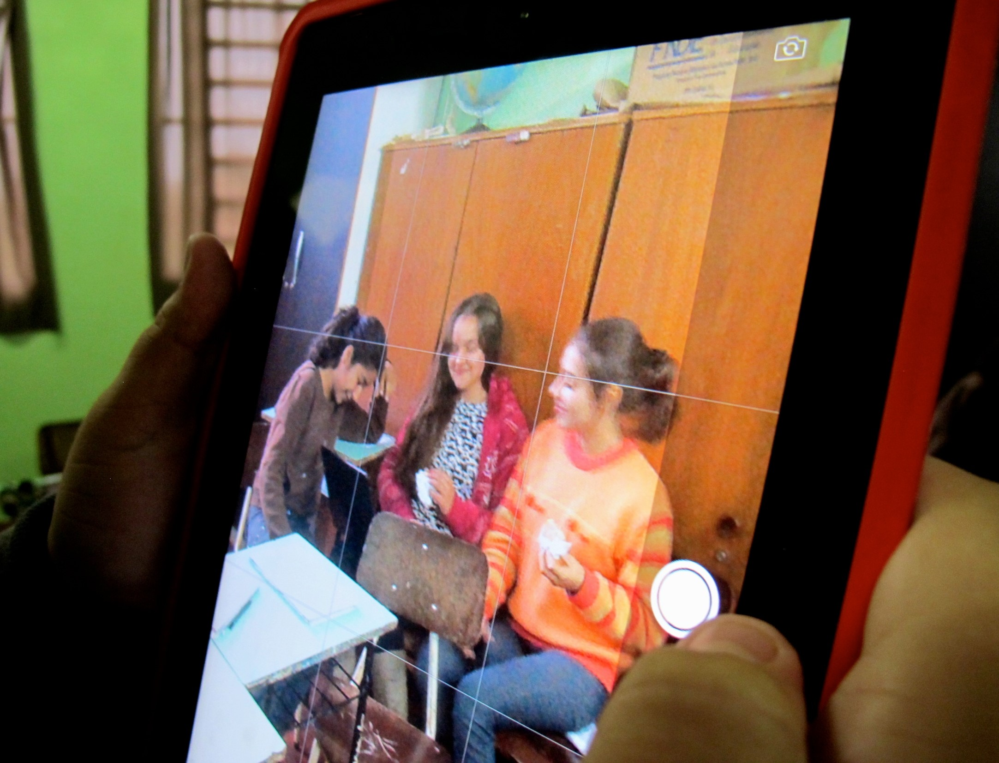
Fig 1. Experimenting with tablets, 2014. Image courtesy Felix Rebolledo Palazuelos.

The second phase was the most problematic, as the acquisition of documentary production techniques and the development of expressive capabilities was the crux of our project—it is here that we sought to be able to instill a method of ethic-aesthetic discovery and creation that would convey the singular expression of self and community through the appropriation of media and its direct subjective use. The work carried out by the students in acquiring the technical skills and crafting their narratives followed the practices of research-creation where the systematic, grounded appraisal of the experiential results was modulated by a processual and experiential mapping practice.
As such, the project was predicated on three phases, which were to come into being and simultaneously co-exist with one another. The first phase was the acquisition of technical skills and the creation of participative videos as experimentation; the second phase involved the record keeping aspect of the experiences as data gathering by the researchers; the third phase consisted of the mapping of experience as everyday life interpretation on the part of the participants. We emphasize the simultaneity of the various aspects of the research process because in contrast to traditional methodologies, which sequentially separate the research protocol into the discrete steps of design, experimentation, data gathering and analysis of results, an important aspect of our research/creation methodology was to investigate the movement of thought that occurs in the intervals between these steps. The principal thrust is not a question of arriving at a Big Conclusion but about the observing and monitoring of the coming to being and deployment of the project’s processual unfolding in order to generate propositions. Therefore, the three phases of the project co-exist as mutually dependent participants in an ecology of practices (Stengers, 2005, p. 183-196).

References:
DELEUZE, Gilles e GUATTARI, Felix. Capitalismo e Esquizofrenia Vol. 2: Mil Platôs. Trad. Brian Massumi. Minneapolis: University of Minnesota Press, 1987.
GUATTARI, Felix. As três ecologias. Trad. I. Pindar e Paul Sutton. Londres: Athlone, 2000.
______________. Chaosmosis: um paradigma ético-estético. Trad. Paul Bains e Julian Pefanis. Bloomington: Indiana University Press, 1995.
LEMOS, André. Cibercultura: Tecnologia e vida social, na cultura contemporânea. Porto Alegre: Editora Sulina, 2010.
______________. Cultura da Mobilidade. Revista FAMECOS, n. 40, p. 28-35, dez. 2009.
MCLUHAN, Marshall; FIORE, Quentin. The Medium is the Massage: An Invention of Effects. New York: Bantam, 1967.
SIMONDON, Gilbert. Du mode d'existence des objets techniques Paris: Aubier, 1958.
STENGERS, Isabelle. Introductory notes on an ecology of practices. Cultural Studies Review, v. 11, n. 1, p. 183-196, 2005.
TOURAINE, Alain. A Method for Studying Social Actors. Journal of World-Systems Research, v. 6, n. 3, Fall-Winter, p. 900-918, 2000.
______________. From understanding society to discovering the subject. Anthropological Theory, v. 2, n. 4, p. 387-398, 2002.

This paper is based on the one published in the Proceedings of the ISEA Dubai 2014 Conference but with additional elaboration on the theoretical aspects of the "Production of Participative Documentaries in the Settlements of the Landless Rural Workers Movement in Brazil" project.
The research project was initially underwritten by a CNPq/SEC/MINc 2013 grant.

